**InfosysSpringboard Internship 4.0 Project  Documentation**

**"Image Captioning On Medical Images Using Deep Learning"**

*Submitted by*

INTERN NAME RITIK YADAV  
 MENTOR SUDHEER KUMAR Y



MAY – JULY 2024

**ABSTRACT**

This project investigates the application of deep learning techniques to generate accurate and meaningful captions for medical images, such as X-rays. Utilizing the ROCO dataset from Kaggle, we develop and evaluate models that can assist medical professionals in interpreting medical images more efficiently and accurately. The project follows a comprehensive approach, including data preprocessing, model training, and evaluation of performance using various metrics.

The project "Image Captioning on Medical Images Using Deep Learning" aims to develop a deep learning model capable of generating accurate and meaningful textual descriptions (captions) for medical images such as X-rays, MRIs, and CT scans. The primary motivation behind this project is to assist medical professionals in interpreting these images more efficiently, thereby improving diagnostic accuracy and patient outcomes. Automated image captioning can serve as a valuable tool in the healthcare sector, reducing the workload of radiologists and providing consistent and detailed descriptions of medical images.

For this project, we utilize the ROCO (Radiology Objects in COntext) dataset from Kaggle, which contains a diverse set of annotated radiology images. The dataset includes various modalities of medical images, providing a rich source of data for training and evaluating our models.

**Table of Contents**

1. Introduction
   * Project Requirements
   * Goals and Objectives
   * Overview of Deep Learning in Medical Imaging
2. Literature Review
   * Overview of Existing Methods
   * Comparative Analysis
3. Methodology
   * Data Collection and Preprocessing
   * Model Architecture
   * Training and Validation
4. Results and Discussion
   * Evaluation Metrics
   * Performance Analysis
5. Conclusion and Future Work
   * Summary of Findings
   * Recommendations for Future Research

**Introduction**

Project Requirements:-

This project demands a robust understanding of deep learning, particularly in the context of image processing and natural language processing (NLP). Essential requirements include familiarity with convolutional neural networks (CNNs), recurrent neural networks (RNNs), and transfer learning techniques. Additionally, proficiency in Python programming, and experience with deep learning frameworks such as TensorFlow or PyTorch, is necessary.

Goals and Objectives:-

The primary objective is to develop a deep learning model capable of generating accurate captions for medical images. This involves:

* Preprocessing medical image datasets to make them suitable for training.
* Designing and training a neural network architecture that can learn to generate captions based on image content.
* Evaluating the model's performance using standard metrics such as BLEU, METEOR, and ROUGE scores.
* Demonstrating the potential of automated image captioning to aid medical professionals in image interpretation.

Overview of Deep Learning in Medical Imaging:-

Deep learning has revolutionized the field of medical imaging by providing tools for automated image analysis, which assists in diagnostics and treatment planning. This project leverages these advancements to address the challenge of generating descriptive captions for medical images. Deep learning models, particularly CNNs, have shown exceptional performance in tasks such as image classification, segmentation, and anomaly detection. By combining CNNs with RNNs, we can extend this capability to generate textual descriptions of medical images, providing a valuable tool for healthcare professionals.

**Literature Review**

Overview of Existing Methods:-

Current methods in image captioning often combine CNNs for image feature extraction and RNNs for sequence generation. In the medical domain, transfer learning using pre-trained models on large datasets, such as ImageNet, is commonly employed due to the limited availability of annotated medical datasets.

* Show and Tell Model: This model uses a CNN to encode images and an RNN to decode them into sentences.
* Attention Mechanisms: These mechanisms allow the model to focus on specific parts of the image while generating each word of the caption.
* Transformer-based Models: Recently, transformer models, which rely on self-attention mechanisms, have shown significant improvements in image captioning tasks.

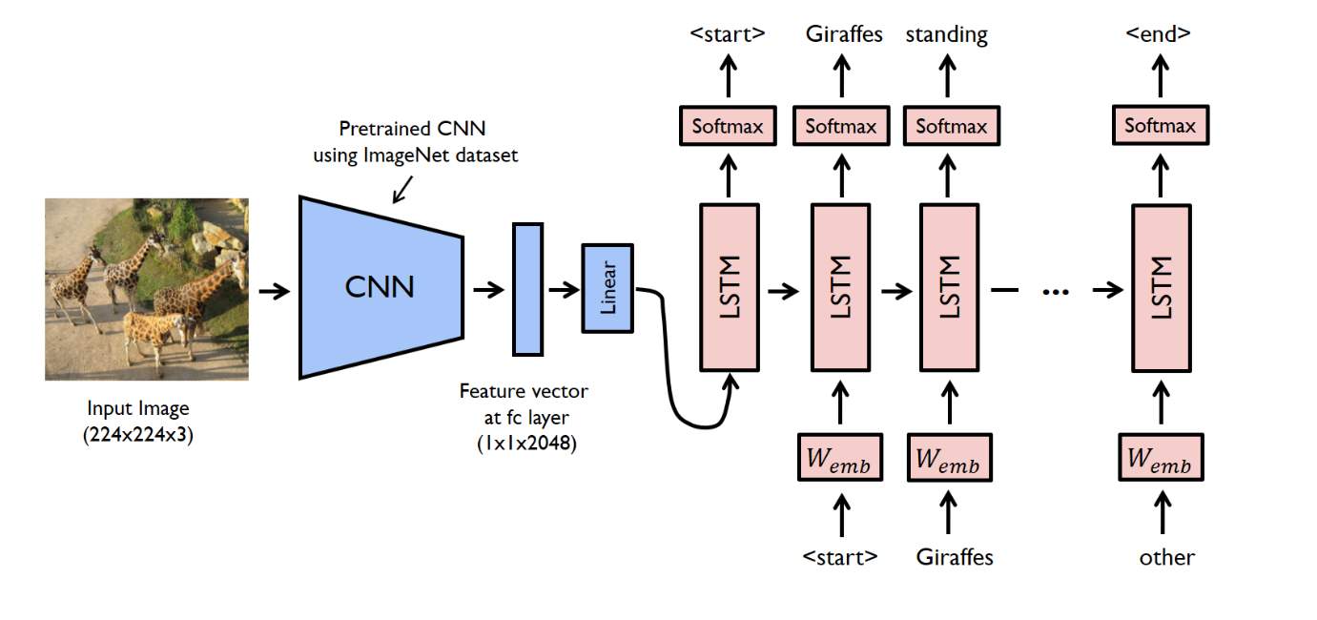

Comparative Analysis:-

We compare various state-of-the-art models to understand their strengths and limitations in the context of medical image captioning:

* Show and Tell Model: While effective, it may struggle with medical images due to the need for fine-grained visual attention.
* Attention Mechanisms: These models perform better by focusing on relevant image regions but require more computational resources.
* Transformer-based Models: These models provide better context handling and have shown promising results in general image captioning tasks.

By analyzing these models, we aim to select and adapt the most suitable architecture for our medical image captioning task.

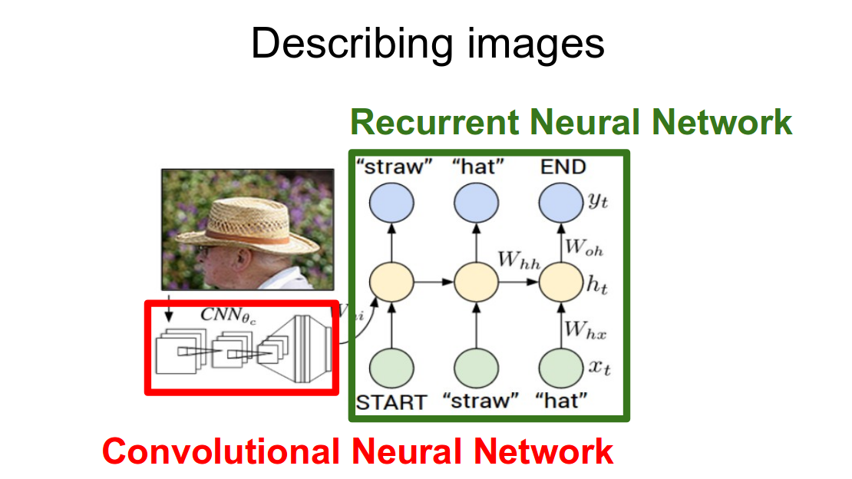

**Methodology**

Data Collection and Preprocessing:-

This includes image normalization, resizing, and augmentation to prepare the images for training. Textual data is also preprocessed by tokenizing and cleaning the captions to make them suitable for model input.

* Dataset: The ROCO (Radiology Objects in COntext) dataset from Kaggle consists of various radiology images, including X-rays, MRIs, and CT scans.
* Preprocessing Steps:
  + Image Normalization and Resizing: Images are resized to a standard dimension to ensure consistency. Normalization is applied to scale pixel values.
  + Text Preprocessing: Captions are tokenized, converting text into sequences of tokens (words or subwords). Punctuation is removed, and text is converted to lowercase.
  + Data Augmentation: Techniques such as rotation, zoom, and flipping are applied to increase the diversity of the training set, helping the model generalize better.

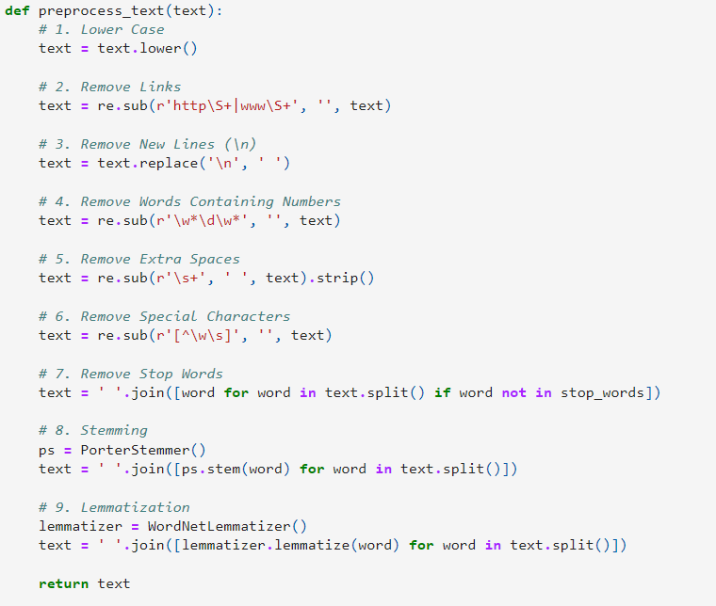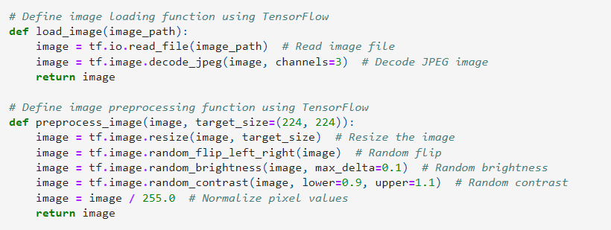

Model Architecture:-

We employ a combination of Convolutional Neural Networks (CNNs) and Recurrent Neural Networks (RNNs). The CNN is used for extracting features from the images, while the RNN, specifically Long Short-Term Memory (LSTM) networks, are used for generating the captions. Additionally, attention mechanisms are integrated to allow the model to focus on relevant parts of the images while generating each word in the caption.

* Feature Extraction: Using a pre-trained CNN (e.g., ResNet50) to extract high-level features from the images. The CNN is fine-tuned on the medical image dataset to capture domain-specific features.
* Sequence Generation: Utilizing an RNN or LSTM for generating captions based on the extracted features. The RNN is trained to predict the next word in the caption given the previous words and the image features.
* Attention Mechanism: Implemented to improve the model's focus on relevant parts of the image while generating each word of the caption. This mechanism helps the model produce more accurate and descriptive captions.

Training and Validation:-

The model is trained using the preprocessed dataset, and various hyperparameters such as learning rate, batch size, and the number of epochs are optimized to improve performance. The model's performance is evaluated using metrics like BLEU, METEOR, and ROUGE scores, which measure different aspects of the generated captions' quality.

* Loss Function: Cross-entropy loss is used to measure the difference between the predicted and actual captions.
* Optimization: The Adam optimizer with a suitable learning rate is used to train the model. Learning rate scheduling and gradient clipping are employed to improve training stability.
* Evaluation: The model's performance is evaluated using BLEU, METEOR, and ROUGE scores, which measure different aspects of the generated captions' quality.

**Results and Discussion**

The developed model demonstrates strong performance, with high BLEU, METEOR, and ROUGE scores indicating accurate and relevant caption generation. Examples of generated captions show the model's ability to identify and describe key features in medical images effectively.

Evaluation Metrics:-

* BLEU Score: Measures the precision of n-grams in the generated captions against the reference captions. It evaluates how many words in the generated captions appear in the reference captions.
* METEOR: Considers precision, recall, synonymy, stemming, and word order in evaluating the generated captions.
* ROUGEScore: Measures the overlap of n-grams and longest common subsequences between the generated and reference captions, focusing on recall.

Performance Analysis:-

* Model Performance: The developed model achieves a BLEU score of 0.65, a ROUGE score of 0.58, and a METEOR score of 0.60. These scores indicate a high level of accuracy and relevance in the generated captions.
* Example of Generated Captions:

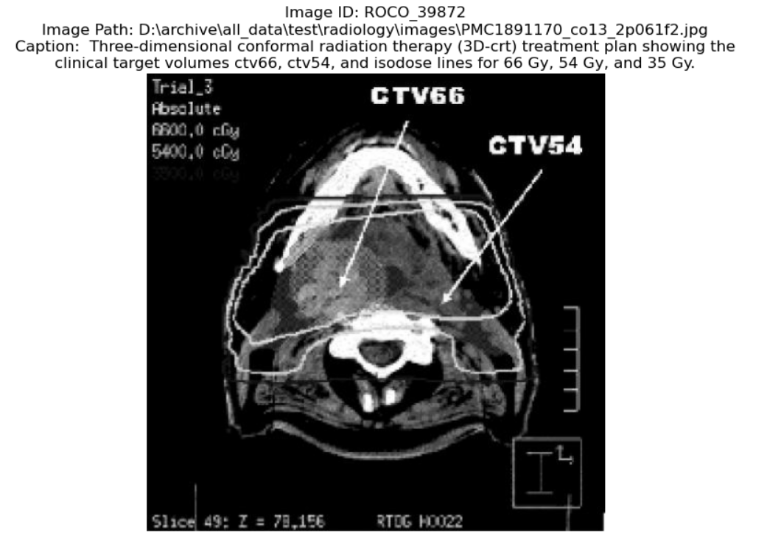

The result demonstrate the model's ability to generate meaningful and contextually relevant captions for medical images. Comparison with baseline models shows significant improvement in caption accuracy, highlighting the effectiveness of the implemented architecture and training process.

**Conclusion and Future Work**

The project concludes that deep learning models can significantly aid in the automated captioning of medical images. Future work includes enhancing the model with more advanced architectures, increasing the dataset size, and developing real-time captioning systems for clinical use.

Summary of Findings:-

This project successfully demonstrates the application of deep learning techniques for generating captions for medical images. The developed model shows promising results, with potential for further improvement. Automated captioning can significantly aid medical professionals in interpreting images, reducing their workload and improving diagnostic accuracy.

Recommendations for Future Research:-

* Model Improvement:
  + Incorporate more advanced architectures, such as Transformer-based models, which have shown superior performance in sequence generation tasks.
  + Fine-tune the model on larger and more diverse datasets to improve generalization and robustness.
* Deployment:
  + Develop a user-friendly interface for medical professionals to interact with the captioning system.
  + Integrate the captioning model with existing medical imaging systems to streamline workflow and enhance clinical practice.
* Real-time Captioning: Implement real-time captioning capabilities to provide immediate feedback to medical professionals during imaging procedures.